Lung Cancer Prediction Model

Cancer is a disease in which cells in the body grow out of control. When cancer starts in the lungs, it is called lung cancer.
Lung cancer begins in the lungs and may spread to lymph nodes or other organs in the body, such as the brain. Cancer from other organs also may spread to the lungs.
Problem statement:
To predict whether the person is diagnosed with lung cancer or not.
Input given to the model:
Patient’s gender,age,bad habits such as smoking and alcohol consumption and symptoms like yellow fingers , anxiety , allergy etc.
Here apart from age we consider 1 and 0 as input for other input properties.
And for gender 1 means “Male” and 0 means “Female”
Here 1 means “Yes” and 0 means “No”
Output given by model:
Predicts whether the patient is suffering with lung cancer or not
Constraints of the model:
This prediction is accurate only for the patient whose age is greater than 45 because we train the model with the data of people greater than age 45.
Explanation:
Why we consider gender as one of the input?
Worldwide, lung cancer is still the most common disease in men and its incidence in women is low.
Although its incidence in women is low, there are large geographical variations depending on the number of women who have taken up smoking.
Generally in India, women smoke less compared to other places.
And also men fall ill at a younger age and have more chronic illnesses than women.
Why we consider age as one of the input?
The incidence of lung cancer increases with age,with 60% of patients being over the age of 65.
Why we consider smoking as one of the input?
According to the study, people who smoke cigarettes are 15 to 30 times more likely to get lung cancer or die from lung cancer than people who don’t smoke.Even smoking a few cigarettes a day or smoking occasionally increases the risk of lung cancer.
Why we consider yellow fingers as one of the input?
In some cases,lung cancer instead of affecting the lungs,these tumors may spread to ribs,nerves etc.
In most of the cases,patients who suffered with lung cancer have a common symptom yellow cases(not in every case but most of the cases).

Why we consider anxiety as one of the input?
In one study,at the time of diagnosis 23%of lung cancer patients were depressed and 16% were anxious.After three months the percentage almost doubled,when 44% reported depressive symptoms.
This percentage increases day by day.
Why we consider chronic disease as one of the input?
Chronic disease and lung cancer are linked diseases.Chronic disease is an independent risk factor for lung related issues.
Chronic diseases are defined broadly as conditions that last for 1 year or more and require medical attention or limit activities of daily living or both.

Why we consider fatigue as one of the input?
Like many other types of cancer ,lung cancer may also cause systemic symptoms ,which are more general in nature. These may include general fatigue.
Why we consider allergy as one of the input?
Depending on the person,they can cause some symptoms that are similar to lung cancer,including a cough,shortness of breath or wheezing .But allergy symptoms include sneezing;a runny,itchy or stuffy nose;swollen eyes or swelling in certain areas of body.

Why we consider wheezing as one of the input?
Wheezing defined as breathe with a whistling and rattling sound in the chest as a result of obstruction in the air passages.
Wheezing is one of the most common symptoms experienced in lung cancer patients ,particularly those with late stage or advanced diseases

Why we consider alcohol consumption as one of the input?
Drinking alcohol is strongly linked with cancers all over the body, from the head and neck to the breasts, liver, colon, and rectum. But studies haven’t shown a clear connection between alcohol and lung cancer.
But drinking often goes hand in hand with other cancer-causing habits, like smoking, which is the No. 1 cause of lung cancer.

Why we consider coughing as one of the input?
The main symptoms of lung cancer include: a cough that doesn't go away after 2 or 3 weeks, a long-standing cough that gets worse.

Why we consider shortness of breath as one of the input?
A distressing symptom of lung cancer is shortness of breath, also called dyspnea, which causes you to have difficulty catching your breath or to feel tightness in your chest. Shortness of breath may come on with physical activity, or even while resting.

Why we consider swallowing difficulty as one of the input?
Many patients with lung cancer experience difficulty in swallowing,a feeling of food stuck in the throat. With some patients, choking on food also occurs.

Why we consider chest pain as one of the input?
When a lung tumor causes tightness in the chest or presses on nerves, you may feel pain in your chest, especially when breathing deeply, coughing or laughing.

Why this model is only predict accurate for the patients with age greater than 45?
Because we trained this model with the data of people with age greater than 45 so it may predict inaccurately for the others.
Regression used while building this model:
Logistic regression:
Logistic Regression is a “Supervised machine learning” algorithm that can be used to model the probability of a certain class or event. It is used when the data is linearly separable and the outcome is binary or dichotomous in nature.
That means Logistic regression is usually used for Binary classification problems.
Binary Classification refers to predicting the output variable that is discrete in two classes.
Here we are using multiple logistic regression(multiple independent variables are used to predict the output).
Code along with output :
Retrieving the data from csv file:
- import pandas as pd
- import numpy as np
- import matplotlib.pyplot as plt
- from sklearn import linear_model
- from sklearn.metrics import mean_squared_error,r2_score
- from sklearn.model_selection import train_test_split
- data=pd.read_csv("survey lung cancer.csv")
- data
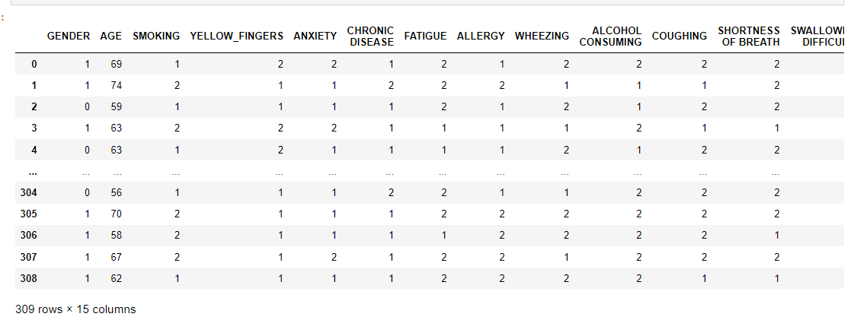
Removing duplicate values:
- data=data.drop_duplicates()
- data
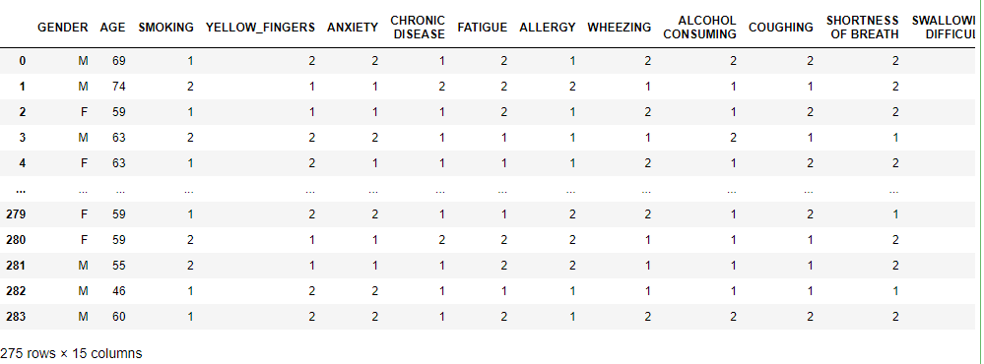
Description about the data:
- data.describe()
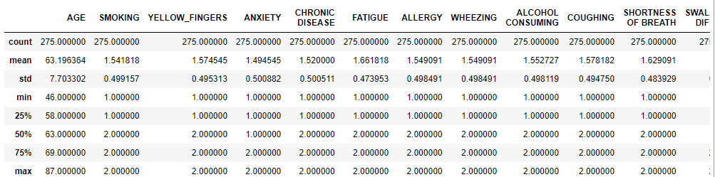
- data.shape
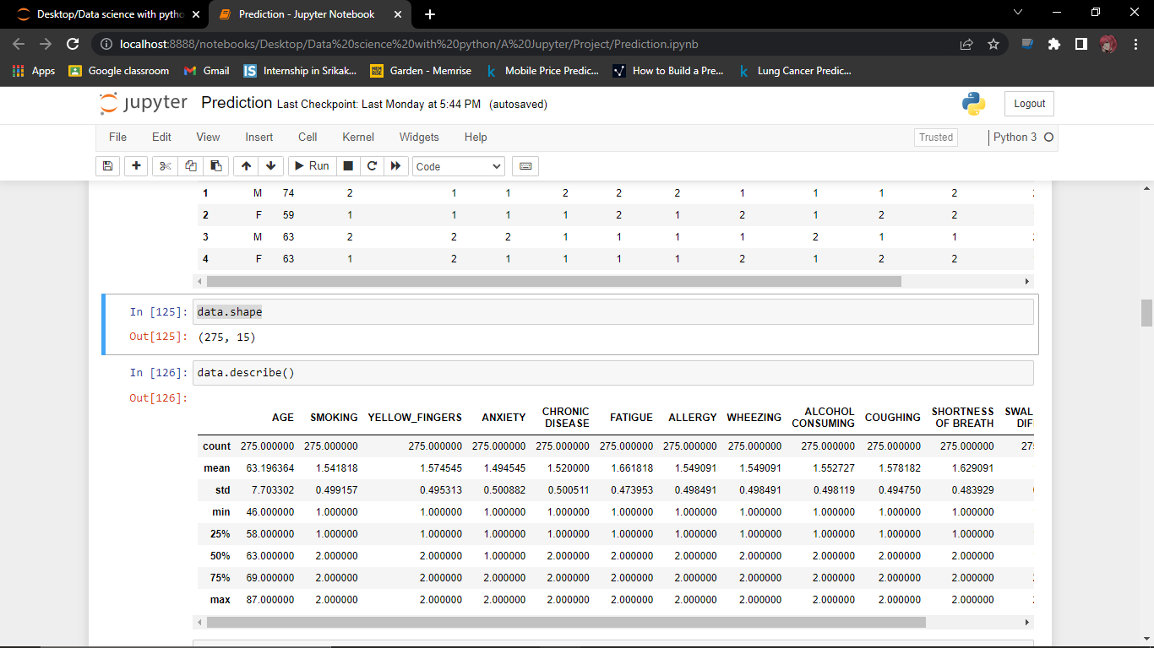
- data.corr()
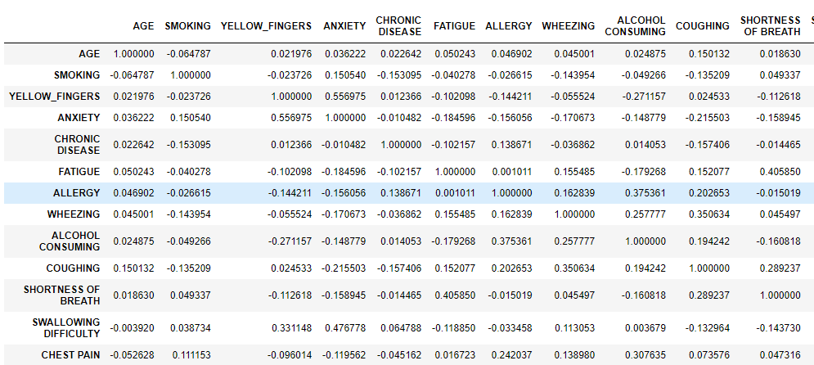
- data.info()
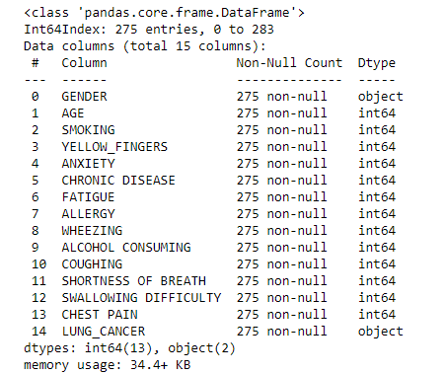
- data.isnull()

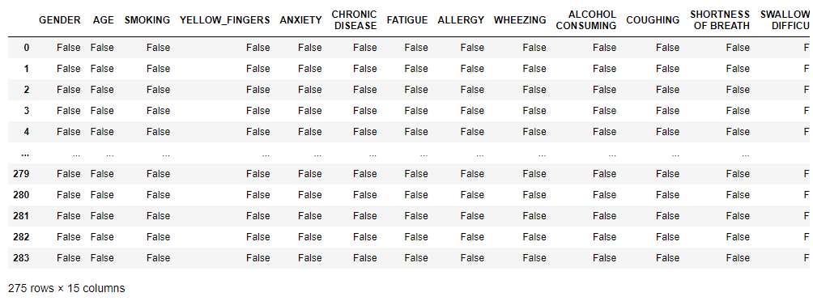
Encoding the data that is retrieved from csv file:
- from sklearn.preprocessing import LabelEncoder
- encoder = LabelEncoder()
- data['GENDER'] = encoder.fit_transform(data['GENDER'])
- data['LUNG_CANCER'] = encoder.fit_transform(data['LUNG_CANCER'])
- data
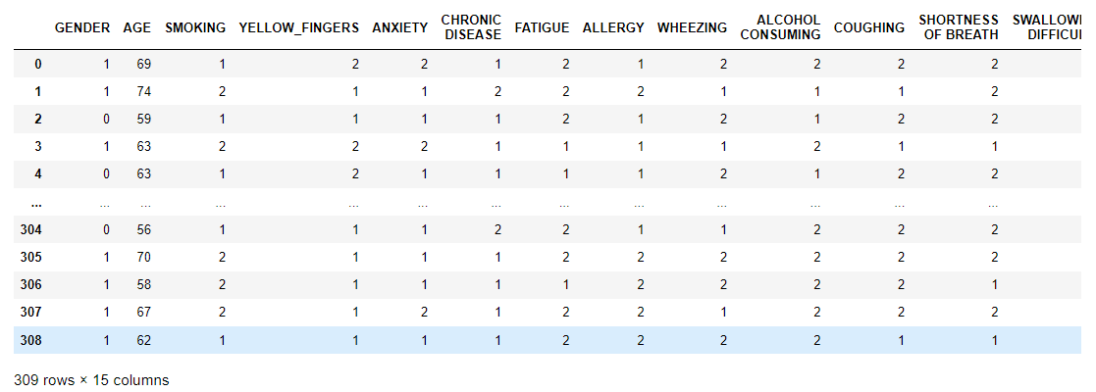
Here some 2 represent yes and 1 represent no.Generally we use 1 to represent yes and 0 to represent no.So for our convenience
We have to replace 2 with 1 and 1 with 0.
- for i in data.columns[2:-1]:
- data[i]=data[i].replace({2:1,1:0})
- data
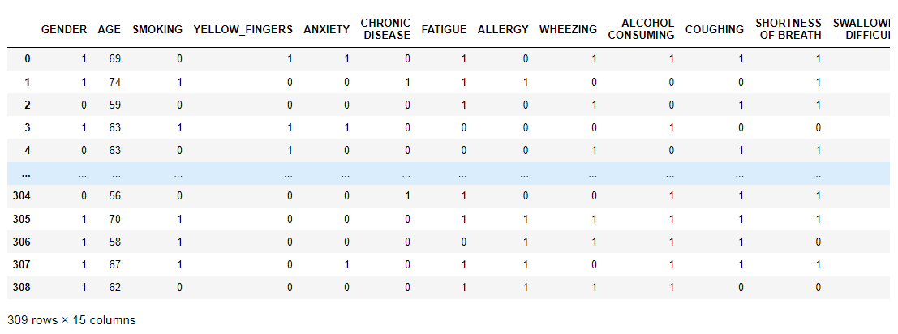

Visualization of data:
- import matplotlib.pyplot as plt
- p=data.value_counts("LUNG_CANCER").to_frame()
- p=p.reset_index()
- p.columns=["x","count"]
- plt.pie(p["count"],labels=["Effected","Not effected"],autopct="%1.1f%%")
- plt.title("Total effected and not effected percentage in the dataset")
- plt.legend()
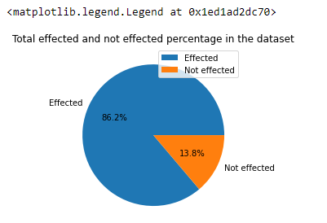
- p=data.value_counts("GENDER").to_frame()
- p=p.reset_index()
- p.columns=["x","count"]
- plt.pie(p["count"],labels=["Male","Female"],autopct="%1.1f%%")
- plt.title("Male and Female percentage in the dataset")
- plt.legend()
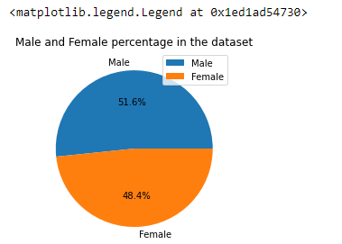
Assigning dependent and independent variables:
- x = data.drop(["LUNG_CANCER"], axis = 1)
- y=data["LUNG_CANCER"]
- x_train, x_test, y_train, y_test = train_test_split(x, y, test_size=0.2)

Model Building :
- from sklearn.linear_model import LogisticRegression
- model = LogisticRegression()
Training the model with th data:
- model.fit(x_train, y_train)
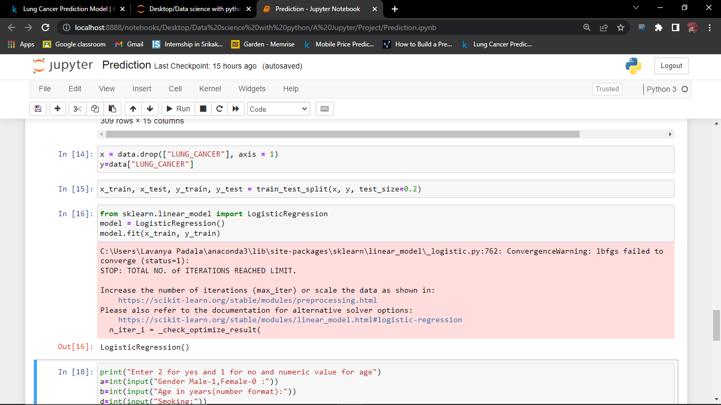
Predicting the value based on the input given by user:
- col=data.columns
- test=[]
- print("Answer the questions according to the following constraints:\nYes:1\nNo:0\nAge in numeric format\nGender=>Male:1\tFemale:0")
- for i in range(len(col)-1):
print(col[i])
t=int(input())
if(col[i]=="AGE"):
if(t<45 or t>90):
print("Invalid input")
break
- else:
if(t<0 or t>1):
print("Invalid input")
break
test.append(t)
- import numpy as np
- test=np.array(test)
- solution=model.predict(np.array(test.reshape(1,-1)))
- if solution==1:
print(colored("Lung cancer","red"))
- else:
print(colored("Not lung cancer","blue"))

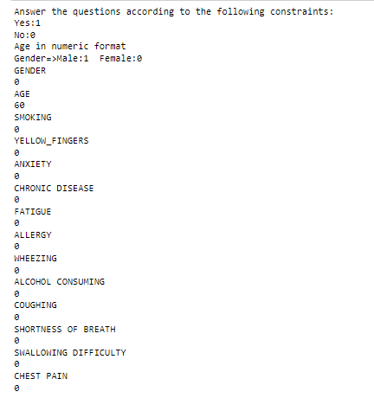
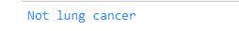
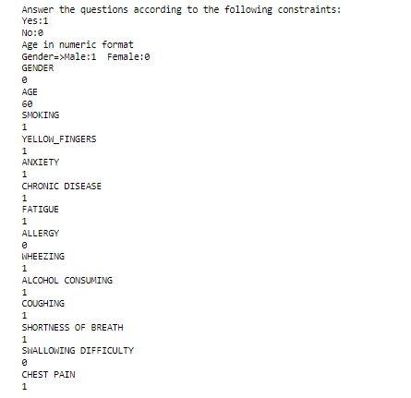
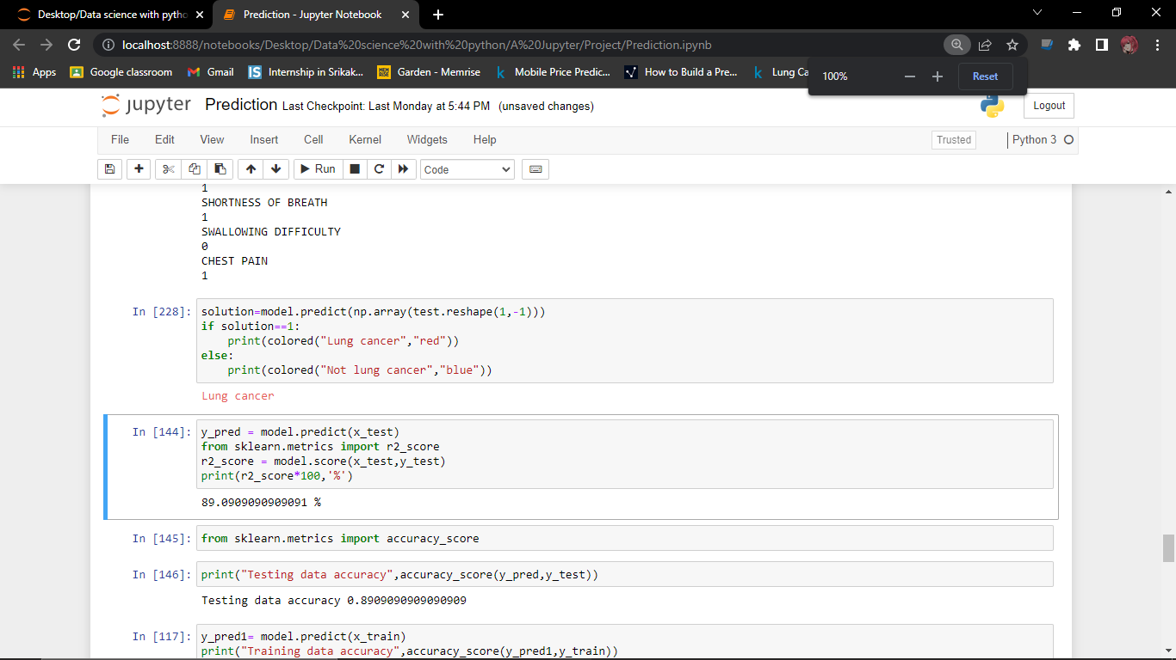
Finding the accuracy of the model:
- from sklearn.metrics import r2_score
- r2_score = model.score(x_test,y_test)
- print(r2_score*100,'%')
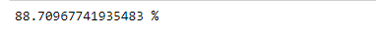
Finding accuracy of training and testing set:
- from sklearn.metrics import accuracy_score
- print("Testing data accuracy",accuracy_score(y_pred,y_test))

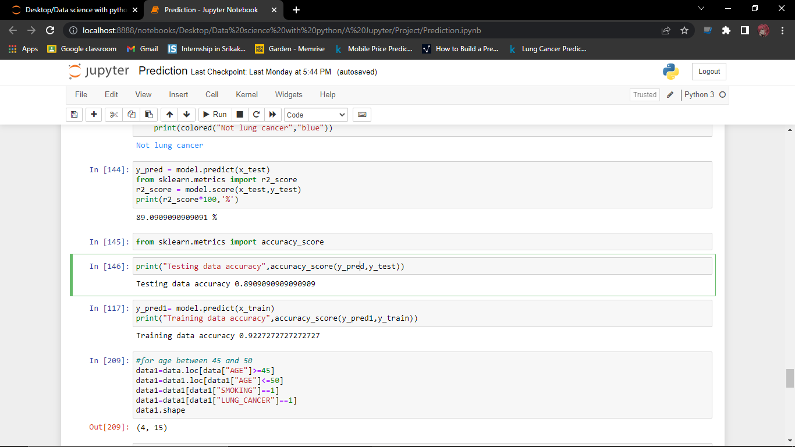
- y_pred1= model.predict(x_train)
- print("Training data accuracy",accuracy_score(y_pred1,y_train))

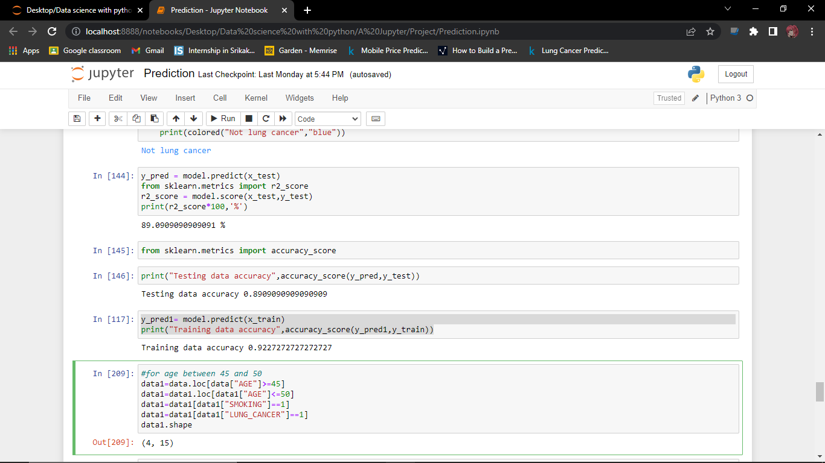
Github repository link:
https://github.com/lavanya-padala/Data-Science-Project.git

Submitted by:
P.Lavanya,
S180317,
CSE-2A,
s180317@rguktsklm.ac.in

